ASSIGNMENT REPORT
DESIGN AND DEVELOPMENT OF A PROCESSOR ARCHITECTURE SIMULATOR FOR ARITHMETIC PROCESSING, PIPELINING AND PERFORMANCE EVALUATION
Particular | Details
Department: | Artificial Intelligence and Data Science
Programme: | B.Tech
Course Code & Course Name | CSA1220- COMPUTER ARCHITECTURE
Academic Year / Batch | 2025-2029
Faculty Name | Dr. S. Radhika
Assignment Title | Design and Development of a Processor Architecture Simulator for Arithmetic Processing, Pipelining and Performance Evaluation
Name /Register number | LAKSHMI DEVI. J (192524300)
Date of Issue | 02-09-2026
Date of Submission | 02-09-2026
Maximum Marks | 100
Course Outcome(s) – CO | CO1: Functional units, instruction cycle, performance metrics. CO2: Integer/floating-point arithmetic algorithms. CO3: Pipelined datapath, hazards, superscalar techniques.
Bloom's Taxonomy Level | L3 – Apply, L4 – Analyze, L5 – Evaluate, L6 – Create
SDG Mapping (SDG 1-17) | SDG 7 – Affordable and Clean Energy; SDG 8 – Decent Work and Economic Growth; SDG 9 – Industry, Innovation and Infrastructure; SDG 12 – Responsible Consumption and Production
Industry / Societal Relevance | Processor performance and energy efficiency directly determine the cost, speed and power draw of every computing device; understanding CPI, pipelining and hazard handling underlies the design of energy-efficient CPUs used across industry (mobile, cloud data-centres, embedded systems).

1. PROBLEM UNDERSTANDING AND FORMULATION

1.1 Problem Statement
A processor performs arithmetic computations and executes instructions through multiple coordinated functional units. In conventional learning, these concepts are often studied independently using static diagrams and numerical examples. This makes it difficult to understand how arithmetic processing, instruction execution, pipelining, hazards and advanced execution techniques collectively affect processor performance. The problem addressed in this project is the absence of a single interactive environment that can demonstrate these interconnected concepts and quantitatively evaluate their performance impact.

1.2 Expected Outcomes
- An interactive web-based simulator of major processor functional units.
- Step-by-step demonstration of instruction fetch, decode, execute, memory access and write-back operations.
- Working simulations of integer arithmetic, Carry Look-Ahead Addition, Booth's multiplication and division algorithms.
- IEEE 754 single- and double-precision representation and floating-point operation visualization.
- A five-stage pipeline simulator with hazard identification and handling.
- Performance evaluation using CPI, clock cycles, execution time, throughput and speedup.
- Comparison of conventional pipelining and simplified advanced execution techniques.

1.3 Available Information and Inputs
The project uses user-provided instructions, integer operands, floating-point values and predefined instruction workloads. No external sensitive dataset is required because the system is algorithm and simulation oriented. The assignment requirements define the required functional units, arithmetic algorithms, pipeline hazards, advanced execution techniques and performance metrics.

1.4 Assumptions
- The baseline processor uses a simplified five-stage pipeline: IF, ID, EX, MEM and WB.
- Each pipeline stage is represented using discrete clock cycles for educational visualization.
- Instruction syntax is limited to a selected set of arithmetic, load/store and branch-style instructions.
- Advanced techniques are simulated at an abstract educational level rather than reproducing a commercial microarchitecture.
- Performance values are calculated consistently from the instruction workload and simulated cycle counts.

1.5 Constraints
The project is constrained by development time, browser-based visualization requirements and the need to keep complex hardware concepts understandable. A complete transistor-level CPU simulation is outside the scope. Therefore, the application emphasizes algorithmic correctness, architectural visualization and comparative performance analysis while maintaining a practical and user-friendly implementation.

2. APPLICATION OF COURSE KNOWLEDGE

2.1 Computer Architecture Principles
The simulator applies fundamental principles of processor organization. The processor model includes registers for temporary storage, an ALU for arithmetic and logical operations, a control unit for sequencing operations, memory for instruction/data storage and buses for data movement. The instruction execution cycle is represented as a sequence of controlled micro-operations.

2.2 Arithmetic Algorithms
Carry Look-Ahead Addition reduces carry propagation delay by using propagate and generate logic. Booth's algorithm is used for signed multiplication and analyses pairs of multiplier bits to determine addition, subtraction or no operation. Restoring and non-restoring division are implemented as iterative algorithms using shifts and arithmetic operations. These algorithms demonstrate how arithmetic hardware can be represented as repeatable register-level operations.

2.3 IEEE 754 Floating-Point Processing
The floating-point module applies the IEEE 754 representation concept using sign, biased exponent and fraction (mantissa) fields. Single precision uses 32 bits and double precision uses 64 bits. The simulator presents these fields separately so that users can observe how a decimal value is encoded and how precision and range differ between formats.

2.4 Pipeline and Performance Models
The pipeline model divides instruction processing into five stages. Multiple instructions can occupy different stages concurrently, increasing throughput. The simulator evaluates the effects of hazards and stalls on performance. The principal equations used are:

Metric | Formula | Purpose
CPI | Total Clock Cycles / Total Instructions | Average cycles required per instruction
Execution Time | Clock Cycles × Clock Cycle Time | Total processing duration
Throughput | Instructions Completed / Execution Time | Rate of instruction completion
Speedup | Non-pipelined Time / Pipelined Time | Improvement due to parallel execution
Pipeline Efficiency | Useful Pipeline Work / Total Pipeline Slots | Utilization of pipeline stages

2.5 Engineering Reasoning
The design separates computation from visualization. Python modules implement the core algorithms, while the web interface sends inputs to Flask endpoints and presents returned results using tables, timelines and charts. This modular approach improves testability and makes it possible to compare alternative execution configurations without changing the entire application.

3. SOLUTION / DESIGN / METHODOLOGY

3.1 Proposed Solution
The proposed solution is an Integrated Processor Architecture Simulator developed as a web application. The system provides independent modules connected through a common interface and performance layer. Users select a concept, provide operands or instructions, run the simulation and observe intermediate steps and final metrics.

3.2 System Architecture
Layer | Components | Responsibility
Presentation Layer | HTML, CSS, JavaScript, Charts | User interaction, diagrams, tables and graphs
Application Layer | Flask Routes / APIs | Input validation and coordination
Simulation Layer | Arithmetic, Pipeline, Hazard and Performance Modules | Algorithm execution and cycle simulation
Analysis Layer | Metric Calculator and Benchmark Module | CPI, throughput, speedup and comparisons

3.3 Functional Modules
Module | Main Function
Dashboard | Provides project overview, quick statistics and summary charts.
Processor Architecture | Visualizes CPU, ALU, control unit, registers, memory, I/O and buses.
Instruction Execution | Demonstrates IF, ID, EX, MEM and WB stages.
Integer Arithmetic | Performs number conversion, signed arithmetic and Carry Look-Ahead Addition.
Arithmetic Algorithms | Implements Booth's multiplication, restoring division and non-restoring division.
IEEE 754 | Converts and visualizes single- and double-precision floating-point representations.
Pipeline Simulator | Shows cycle-by-cycle execution of multiple instructions.
Pipeline Hazards | Detects data, control and structural hazards and demonstrates handling.
Advanced Execution | Provides simplified out-of-order, speculative execution and SMT comparisons.
Performance Analysis | Computes CPI, cycles, execution time, throughput and speedup.

3.4 Methodology
- Study assignment requirements and identify the required Computer Architecture concepts.
- Design the modular web application architecture.
- Implement arithmetic algorithms independently and validate them with test cases.
- Develop processor and instruction-cycle visualizations.
- Construct the five-stage pipeline timing simulation.
- Introduce hazard detection and handling strategies.
- Add performance calculation and benchmarking functionality.
- Integrate all modules through Flask APIs and validate end-to-end operation.

4. REQUIREMENTS AND CONSTRAINTS

4.1 Functional Requirements
- The system shall accept user input for arithmetic operands and processor instructions.
- The system shall display major processor functional units and data movement.
- The system shall execute arithmetic algorithms and provide intermediate steps.
- The system shall support IEEE 754 representation visualization.
- The system shall simulate pipelined execution across five stages.
- The system shall identify and demonstrate pipeline hazards.
- The system shall calculate and display performance metrics.
- The system shall compare different processor execution configurations.

4.2 Non-Functional Requirements
Requirement | Description
Usability | Interface should be understandable for students learning processor concepts.
Correctness | Algorithm outputs should be validated using representative test cases.
Performance | Interactive operations should return results without noticeable delay for normal workloads.
Reliability | Invalid inputs should be handled with meaningful error messages.
Maintainability | Code should be modular and organized by simulator function.
Portability | Application should run through a standard Python environment and web browser.
Sustainability | Software simulation avoids the need for dedicated hardware experimentation for basic learning.

4.3 Technical Constraints
The simulator is software-based and therefore does not model exact electrical timing, transistor behavior, cache coherence or all proprietary microarchitectural features. Browser visualization also limits the amount of information that can be displayed simultaneously. The project addresses these constraints through abstraction and interactive step-by-step views.

USE OF MODERN TOOLS
Tool / Technology | Purpose
Python | Core simulation and algorithm implementation
Flask | Backend framework and API routing
HTML5 | Web page structure
CSS3 / Bootstrap | Responsive interface and styling
JavaScript | Interactive controls and dynamic visualization
Chart.js | Performance graphs and comparisons
Visual Studio Code | Source code development and debugging
Web Browser | Running and demonstrating the simulator

Modern development tools are used to convert theoretical processor concepts into an interactive application. Evidence of implementation should be included in the final submitted report through screenshots of the running interface, terminal execution and representative module outputs.

6. RESULTS AND VALIDATION

6.1 Validation Strategy
Each module is validated by comparing simulated output with expected mathematical or architectural behavior. Arithmetic operations are tested using positive and negative values. Multiplication and division results are checked against conventional arithmetic. IEEE 754 fields are verified against the expected binary representation. Pipeline simulations are validated by manually checking stage movement and stall insertion for selected instruction sequences.

6.2 Representative Test Cases
Module | Sample Input | Expected Validation
Integer Addition | 25 + 17 | Binary and decimal result match conventional addition
Signed Arithmetic | -12 + 7 | Correct two's-complement signed result
Booth's Multiplication | -7 × 6 | Final signed product equals -42
Restoring Division | 29 ÷ 5 | Quotient = 5, Remainder = 4
IEEE 754 | Decimal floating-point input | Correct sign, exponent and mantissa decomposition
Pipeline | Dependent instruction sequence | Data hazard and stall/forwarding behavior visible
Control Hazard | Branch-style instruction | Prediction/flush penalty reflected in cycles

6.3 Expected Interface Evidence
- Screenshot 1: Main dashboard of the running web application.
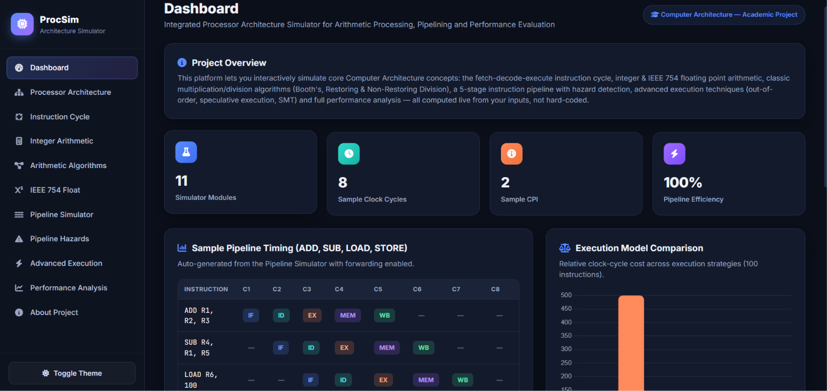

- Screenshot 2: Processor architecture visualization.
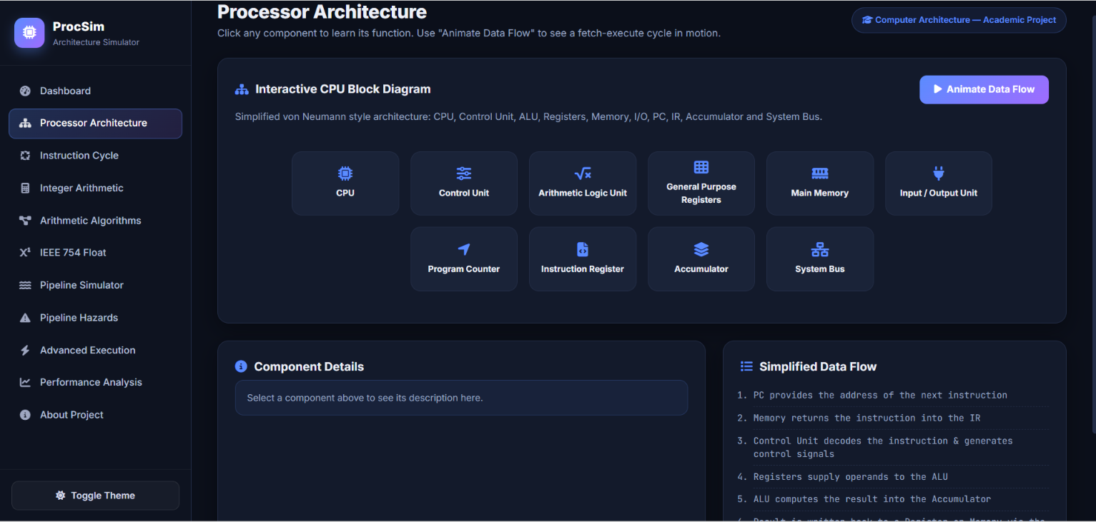

- Screenshot 3: Instruction execution cycle demonstration.
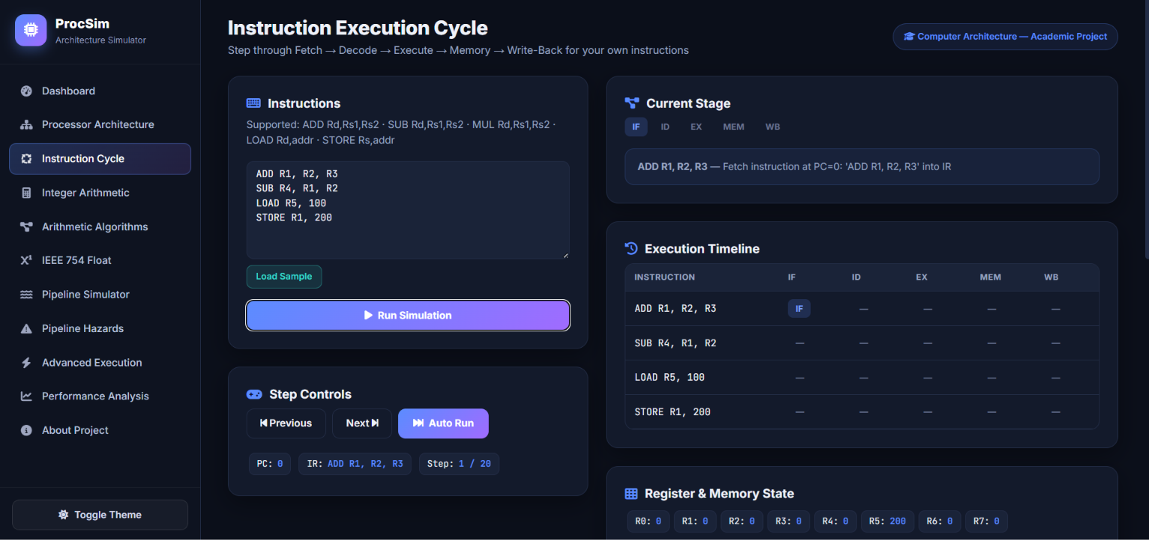

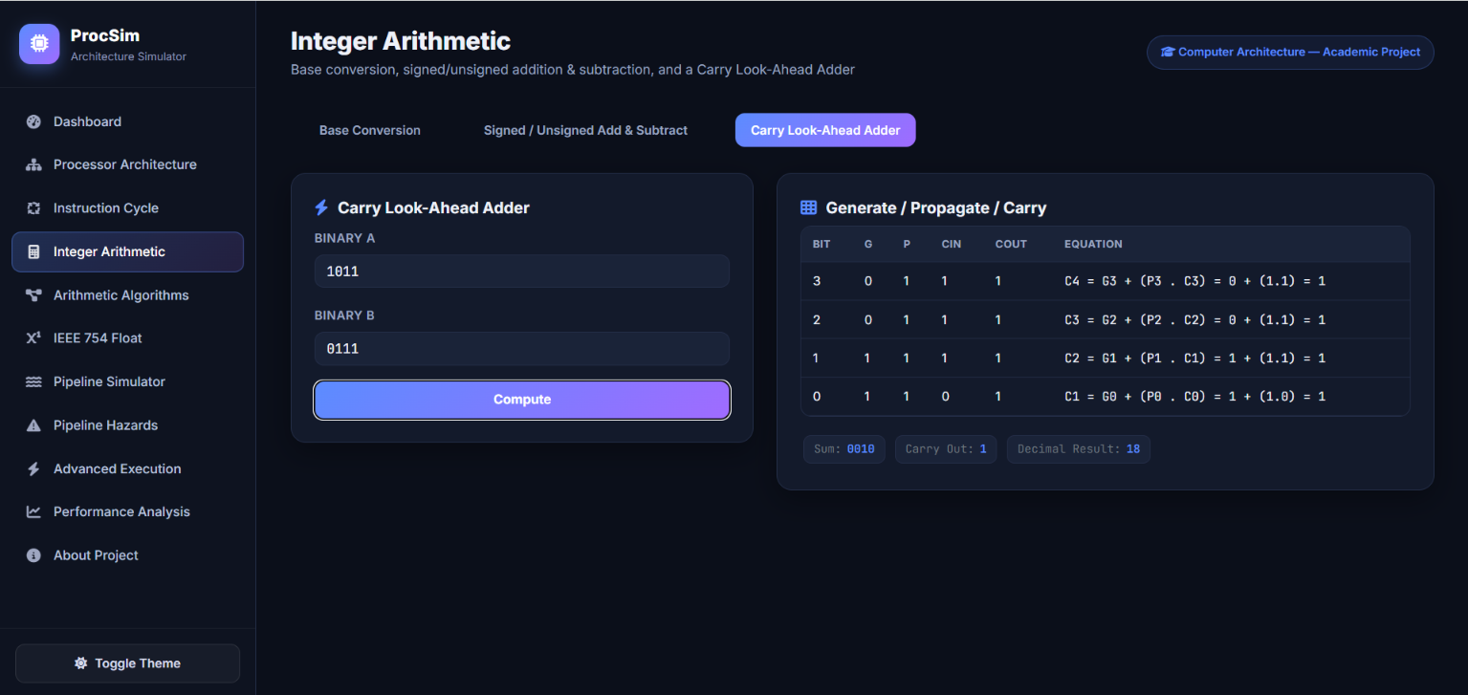

- Screenshot 4: Booth's multiplication iteration table.
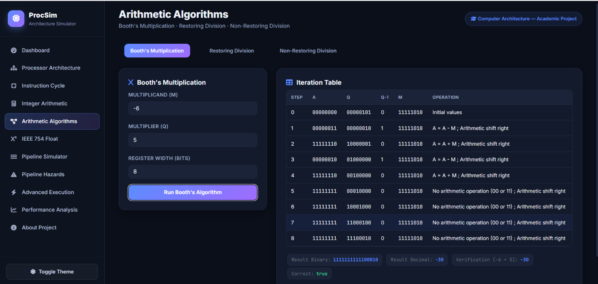

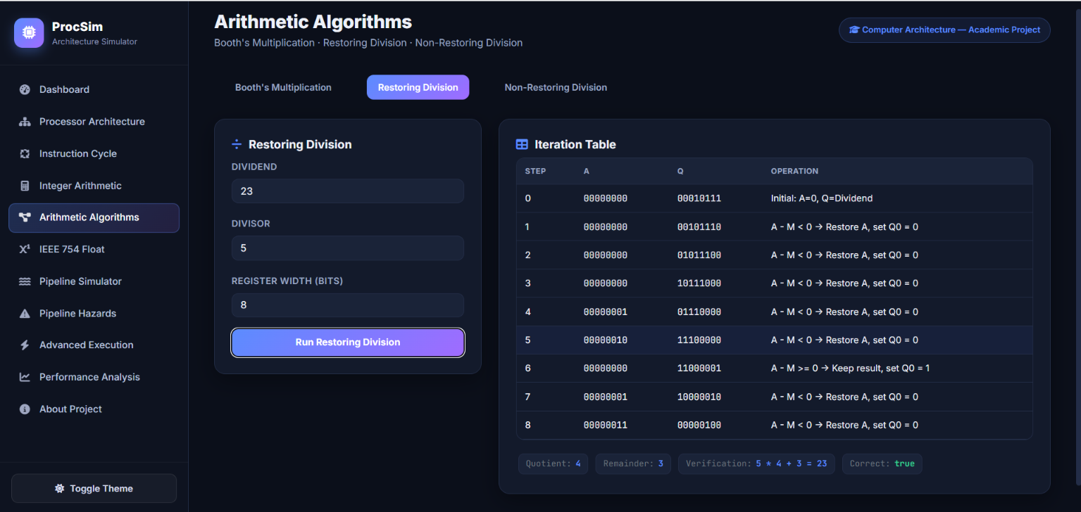

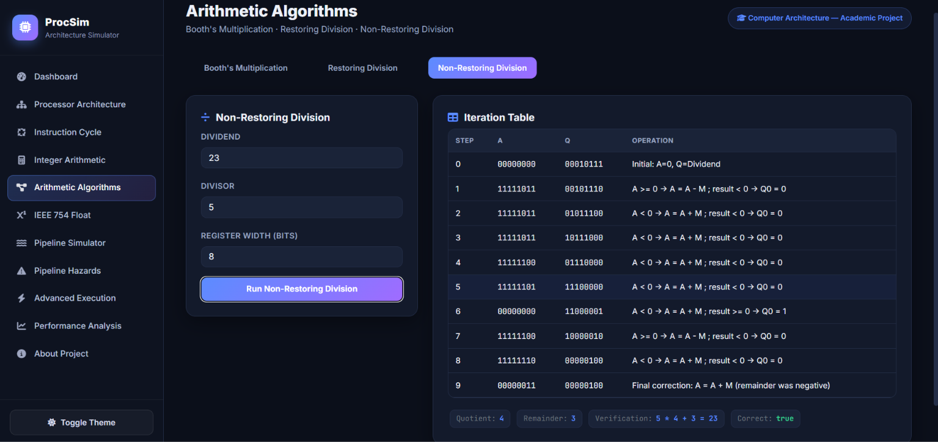

- Screenshot 5: IEEE 754 sign, exponent and mantissa visualization.
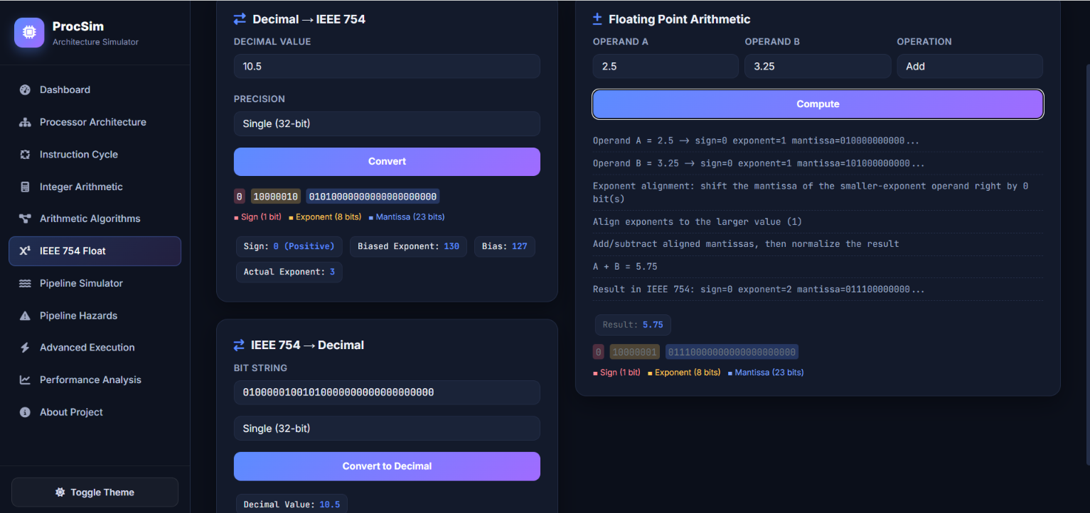

- Screenshot 6: Five-stage pipeline timing diagram.
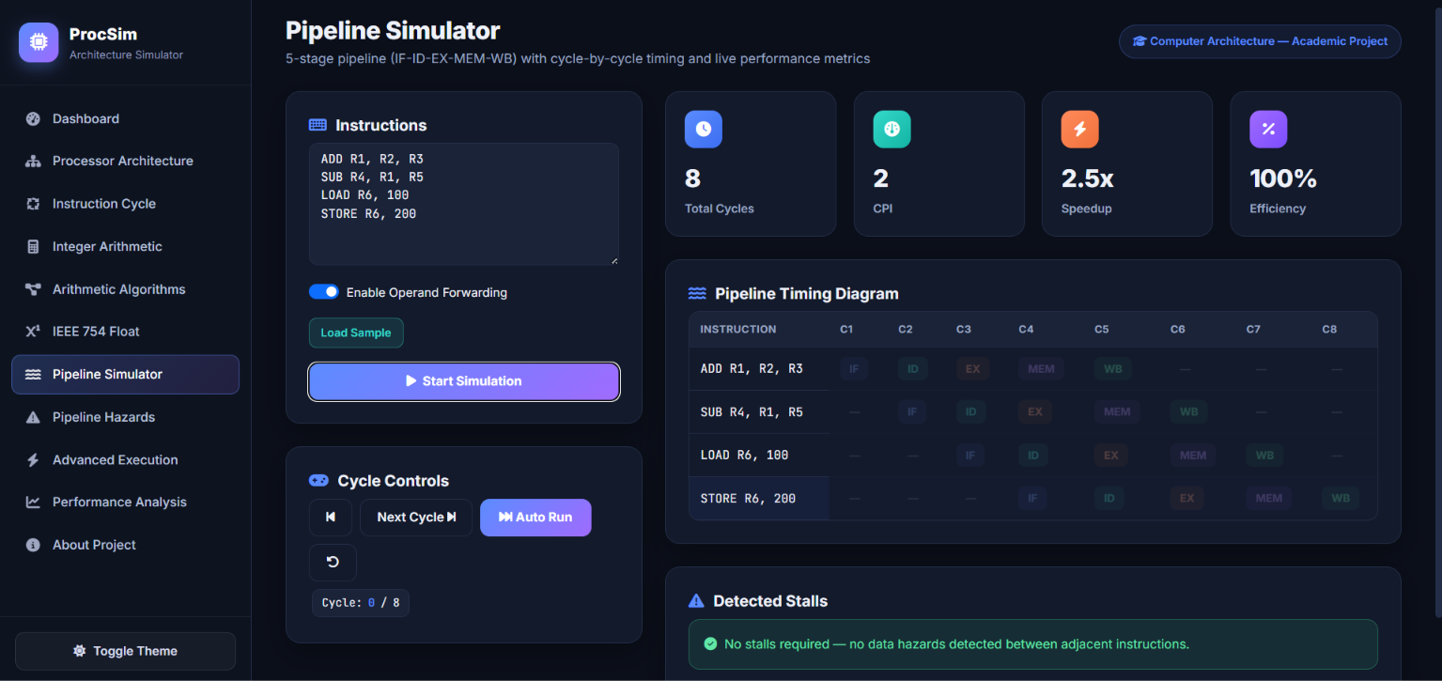

- Screenshot 7: Pipeline hazard handling comparison.
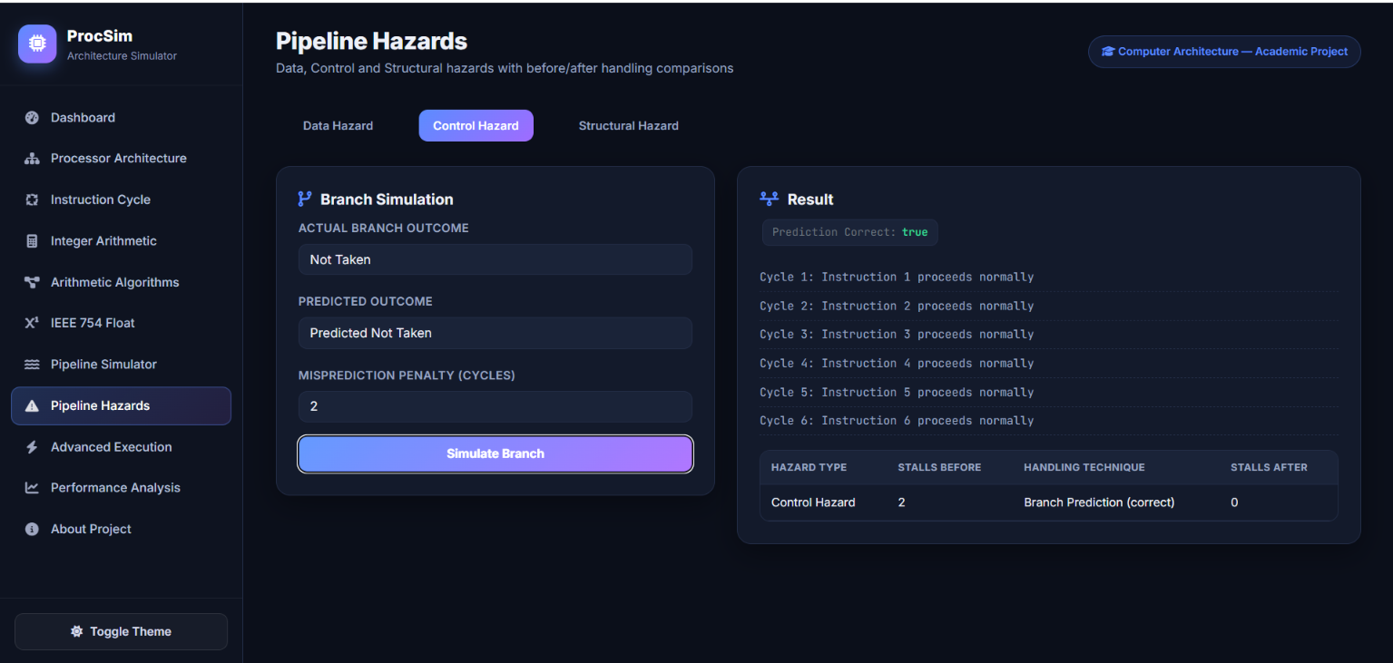

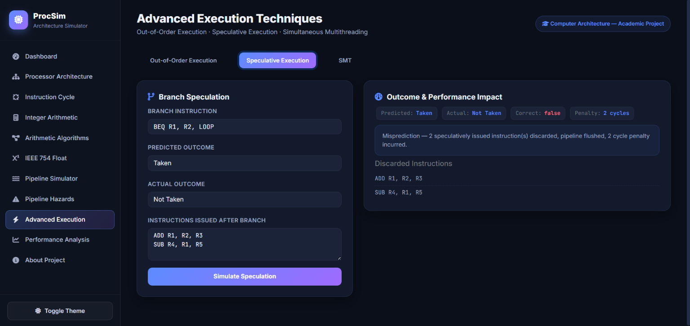

- Screenshot 8: Performance dashboard with charts.
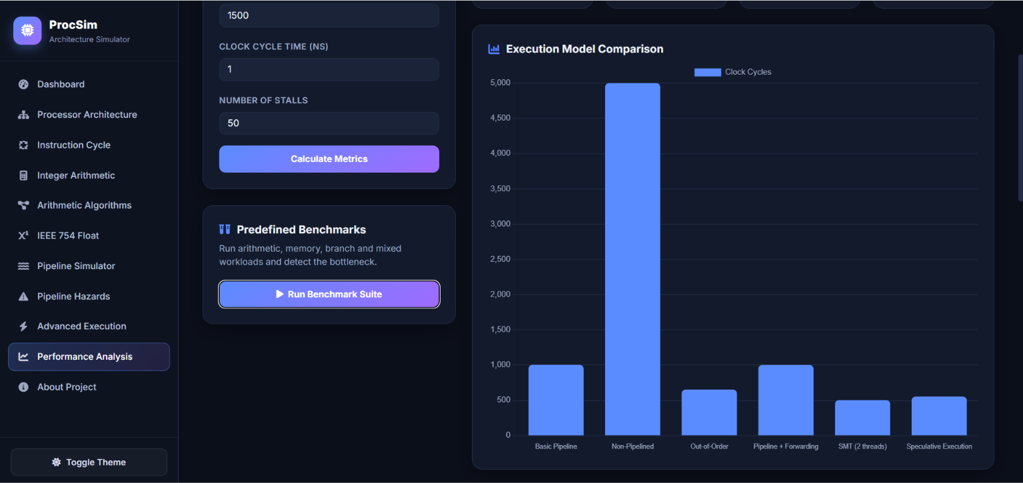

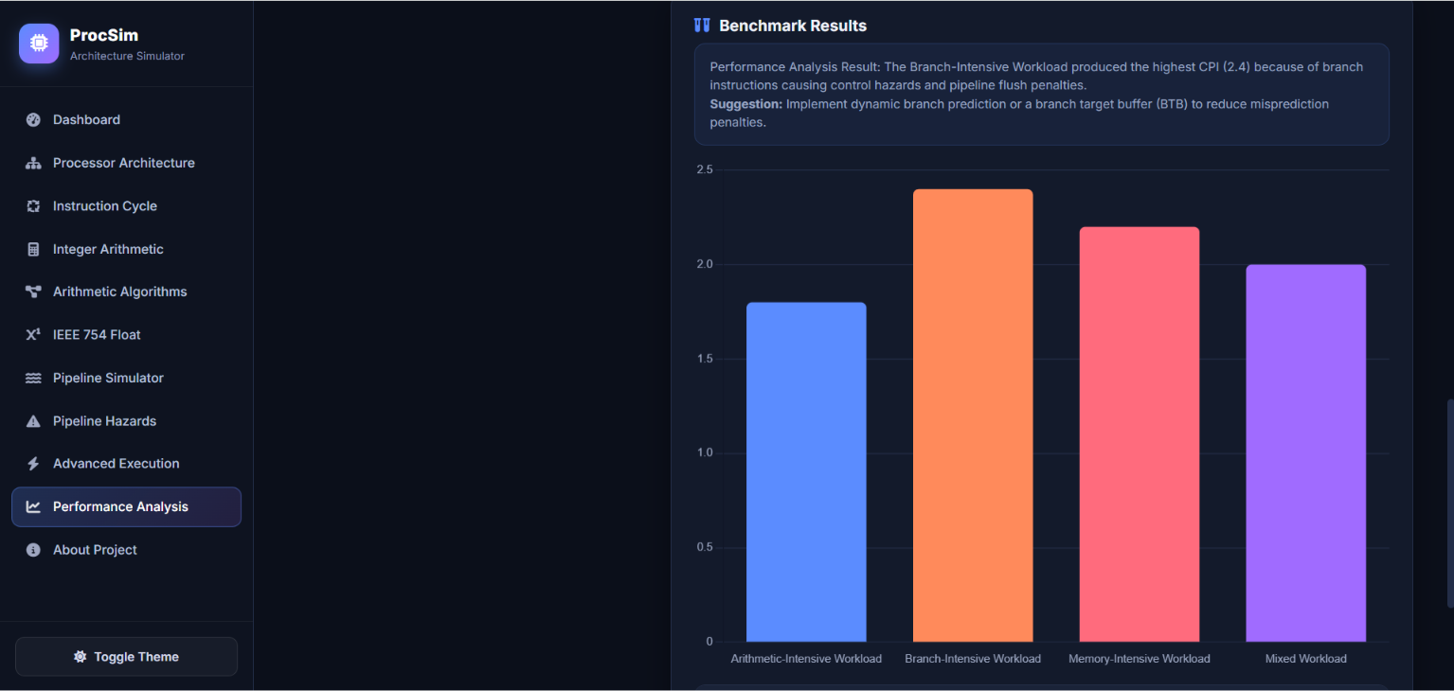
NOTE: Insert your own screenshots from the completed application at these locations before final submission.

7. ANALYSIS AND ENGINEERING DECISION

7.1 Pipelined versus Non-Pipelined Organization
A non-pipelined processor completes an instruction before beginning the next major execution sequence, whereas pipelining overlaps stages of multiple instructions. The simulator demonstrates that pipelining can improve throughput but does not eliminate latency for an individual instruction. The actual improvement depends on balanced stages and the frequency of hazards.

7.2 Hazard Handling Trade-Offs
Technique | Advantage | Limitation
Stalling | Simple and reliable | Increases clock cycles and CPI
Forwarding | Reduces many data stalls | Requires additional data paths and control logic
Branch Prediction | Can improve control-flow performance | Incorrect predictions cause penalties
Resource Duplication | Reduces structural conflicts | Increases hardware cost and complexity

7.3 Advanced Execution Comparison
Out-of-order execution can improve functional-unit utilization by executing ready instructions before earlier blocked instructions. Speculative execution can reduce branch waiting when predictions are correct, while simultaneous multithreading improves utilization by allowing multiple threads to share execution resources. These approaches improve potential throughput but introduce greater scheduling, control and hardware complexity. Therefore, the final simulator presents them as comparative configurations rather than assuming that one technique is universally optimal.

7.4 Final Design Decision
A web-based modular simulator was selected because it combines accessibility, portability and visual interaction. Python Flask provides a straightforward method for implementing algorithms, while JavaScript and charts provide immediate visual feedback. The five-stage pipeline was selected as the baseline because it clearly represents standard instruction processing and makes the effect of hazards easy to observe.

8. BROADER CONSIDERATIONS

8.1 Sustainability and SDG Relevance
The project relates to SDG 7 (Affordable and Clean Energy), SDG 9 (Industry, Innovation and Infrastructure) and SDG 12 (Responsible Consumption and Production). Efficient processor design can reduce unnecessary execution cycles and improve computational energy efficiency. Simulation-based learning reduces dependence on dedicated physical hardware for introductory experimentation and supports scalable digital education.

8.2 Societal and Educational Impact
The simulator can help students connect abstract processor theory with observable behavior. Interactive visualization improves conceptual understanding and can reduce the barrier to studying advanced topics such as pipelining and floating-point processing. A browser-based approach also improves accessibility because the application can be demonstrated on common computing systems.

8.3 Professional and Ethical Considerations
The application should clearly state that it is an educational abstraction and should not be presented as an exact model of any commercial processor. Algorithm results and performance conclusions must be based on the simulator's assumptions. Proper acknowledgement should be given for external standards, documentation, libraries and AI-assisted development tools used during implementation.

9. CONCLUSION
This project presents an Integrated Processor Architecture Simulator for Arithmetic Processing, Pipelining and Performance Evaluation. The proposed web-based system brings together processor functional units, instruction execution, integer arithmetic, arithmetic algorithms, IEEE 754 floating-point processing, pipelining, hazard analysis, advanced execution concepts and quantitative performance evaluation in a single application.

The modular design enables individual concepts to be studied independently while also showing their relationship to overall processor performance. Arithmetic modules provide step-wise algorithm execution, while pipeline and hazard modules demonstrate how instruction dependencies influence clock cycles and CPI. The performance layer converts simulation behavior into measurable values such as execution time, throughput and speedup.

The main limitation is that the simulator uses an abstract educational processor model rather than a cycle-accurate reproduction of modern commercial CPUs. Future enhancements can include cache hierarchy simulation, branch predictor accuracy models, configurable pipeline depth, dynamic instruction scheduling, multicore execution and exportable benchmarking reports. Overall, the project satisfies the objective of transforming Computer Architecture concepts into an interactive, analyzable and demonstrable software system.

10. STUDENT REFLECTION
This assignment helped me understand that processor performance is not determined only by clock frequency or arithmetic speed. I learned how multiple architectural components interact during instruction execution and how a small dependency between instructions can influence the overall CPI and throughput of a pipelined processor. Implementing the concepts as a simulator made algorithms such as Booth's multiplication, division and IEEE 754 representation more understandable because each intermediate operation could be observed instead of memorized.

I also learned the importance of abstraction in engineering design. A real modern processor is extremely complex, so designing an educational simulator required selecting the most important components and representing them in a simplified but meaningful manner. Integrating backend algorithms with a web interface improved my understanding of how theoretical engineering concepts can be converted into usable software tools.

Given additional time and resources, I would improve the project by adding cache and memory hierarchy simulation, configurable pipeline architectures, more realistic branch prediction policies, multicore scheduling and automated benchmark report generation. I would also add more interactive animations and a larger library of instruction workloads to make performance comparisons more comprehensive.

11. REFERENCES
- J. L. Hennessy, D. A. Patterson, and C. Kozyrakis, Computer Architecture: A Quantitative Approach, 7th ed., Morgan Kaufmann, 2025. The 7th edition covers instruction-level parallelism, pipelining, computer arithmetic, and modern processor architectures.
- W. Stallings, Computer Organization and Architecture: Designing for Performance, Pearson, 2024.
- IEEE Computer Society, IEEE Standard for Floating-Point Arithmetic, IEEE Standards Association, 2024. This reference is relevant to the IEEE 754 floating-point module in the project.
- ISO/IEC/IEEE, ISO/IEC/IEEE 60559:2020 — Floating-Point Arithmetic, IEEE Standards Association, 2024.
- J. L. Hennessy, D. A. Patterson, and C. Kozyrakis, Computer Architecture: A Quantitative Approach, 7th ed., Morgan Kaufmann, 2025 — sections on instruction-level parallelism, pipelining, and quantitative performance analysis.
- Pallets Projects, Flask Documentation, Version 3.1, Pallets, 2025. Used as a reference for the Flask web application and API structure used in the simulator.
- Chart.js Contributors, Chart.js Documentation, 2025. Used as a reference for implementing interactive performance graphs and charts in the web application.
- IEEE Computer Society, IEEE Standard for Floating-Point Arithmetic (IEEE 754), IEEE, 2024. Relevant to the project's sign, exponent, fraction/mantissa representation and floating-point operations.
- Python Software Foundation, Python 3 Documentation, Python Software Foundation, 2025. Used as a reference for implementing the arithmetic algorithms, processor simulation logic and backend computation.
- ·Hennessy, Patterson, and Kozyrakis, Computer Architecture: A Quantitative Approach, 7th ed., Morgan Kaufmann, 2025 — reference for performance metrics, instruction-level parallelism, pipeline concepts and processor design trade-offs.

